Unit 2 Review:
Vocabulary (Definitions: Pg 110, pg 142.):

Point of View
Dialogue
Dialogue Tags
Persona
Theme
Symbols
Narrative Pacing
Sequence of Events
Setting
Direct/Indirect Characterization
Gutter
Panel
Dialogue Balloons
Thought Bubbles
Captions
Sound Effects

Examples: Kaffir Boy (pg 122, Funny in Farsi pg 117)
Ethos, Logos, Pathos (pgs 190-194)
Understand both the definition of the three main forms of rhetorical argument and be able to recognize examples.

Review: Bear Paw Mountain, On Women’s Right to Vote, On Civil Disobedience pg 190-194

Persepolis Graphic Novel Excerpt and Terms ( pg 142-151)
Review elements of a panel and be able to label them.
Example:
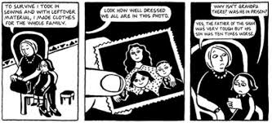
Does this set of panels have any of the following?

Gutter
Dialogue Balloons
Thought Bubbles
Captions
Sound Effects

